1. JavaScript Interactively

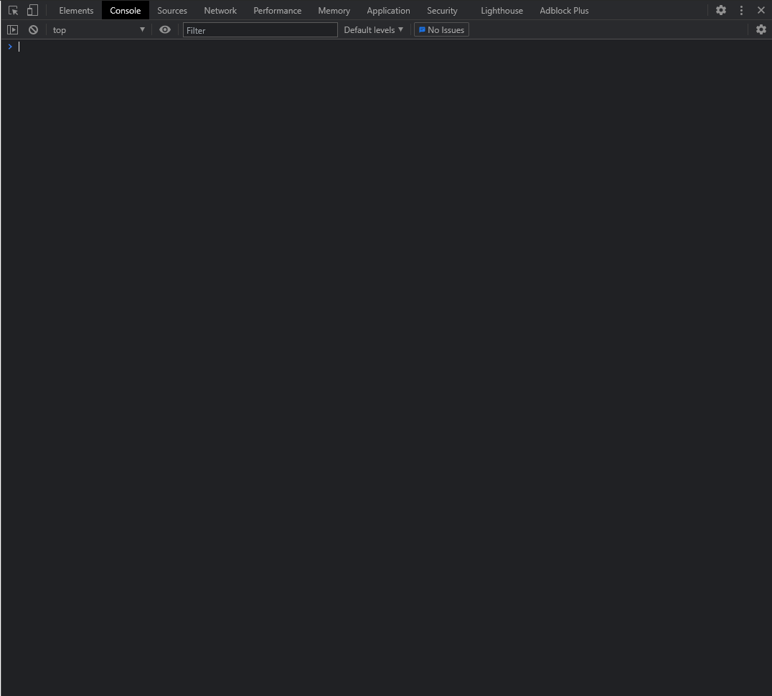

2.Define a variable x and give it a value of 5. Evaluate x and verify it shows the value.

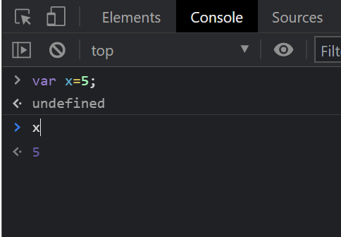

3.Enter this function.....and see whether you are right.

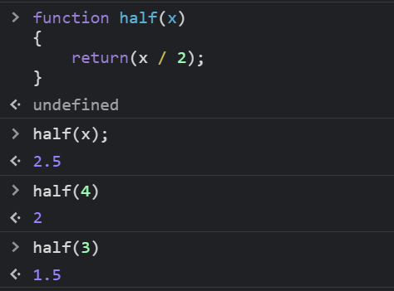

4.Try to predict what you will get if you enter x.

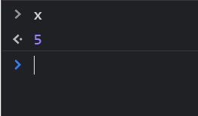

5.Enter the function....... .How will you explain the result?

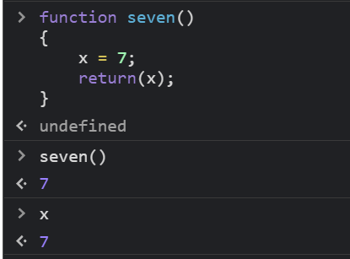

Since **x** is the variable with the **global scope,** so it could be directly accessed by the function seven (). So, it can be manipulated from the function and gives the output  **x=7**.

6.Make a function called calculation. Try some inputs and check the results.

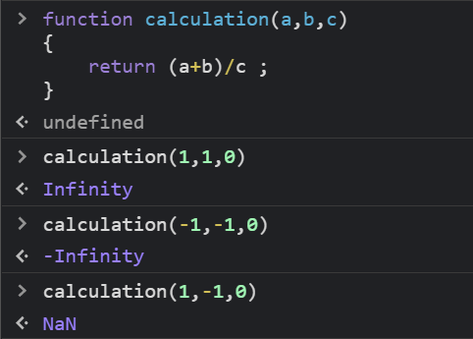

7.Try the “more powerful approach”.

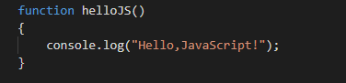 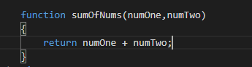

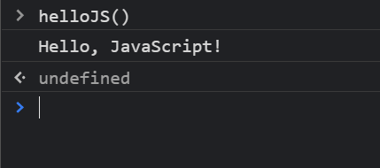 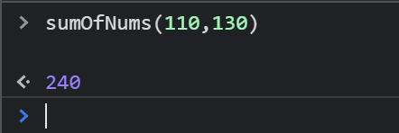

8.Write a function called isEven().

